SIMATS ENGINEERING (SAVEETHA SCHOOL OF ENGINEERING)
Department of Artificial Intelligence and Data Science
ASSESSMENT TOOL 2 – SCENARIO BASED

Course Code: | DSA03 | Course Title: | Natural Language Processing
CO Assessed: | CO2 – Manipulation | Assessment: | Assessment Tool 2 – SCENARIO BASED
Weightage: | 35% of CIA
CO5 Statement: | Design inflectional, derivational, finite-state parsing, stemming algorithms and for analyse morphological methods. (BL-3)
Student Name: | G. Aswartha Manidheep | Reg. No.: | 192425089
Section / Batch: | Btech AI & ML | Date:

Code of Conduct

I G. Aswartha Manoidheep (Name / Reg No) certify that this submission is my original work and that I have adhered to the guidelines specified for this assessment. I understand that any violation of academic integrity rules will result in disciplinary action.
Signature of the Student:

Instructions
- Read all questions carefully before attempting the answers.
- Answer all five questions. Each question carries equal marks.
- Show all intermediate steps, calculations, probability computations, tagging decisions, and justifications wherever applicable.
- Duration: 30 minutes.

Section / Topic | Focus | Q Nos
English Word Classes, Tagsets for English, Stochastic Part of Speech Tagging, HMM | Morphological parsing of disagree, agreement, and agreeable; identification of prefixes, suffixes, base forms, and semantic effects of derivation. | Q1

Annexure A – SCENARIO BASED
A company is developing an NLP-based grammar checker for educational applications. The system is trained using a manually POS-tagged corpus. Your task is to recreate the Hidden Markov Model (HMM) without using any built-in NLP or HMM libraries.
From the given corpus,
- determine the Emission Probability
- determine the Transition Probability
- implement the Viterbi Algorithm
- predict the POS tags for the new input sentence.
Use only Python dictionaries, loops, and basic programming constructs.

Training Corpus
Sentence | POS Tags
The/DT boy/NN eats/VBZ rice/NN | DT NN VBZ NN
The/DT girl/NN drinks/VBZ milk/NN | DT NN VBZ NN
A/DT cat/NN drinks/VBZ milk/NN | DT NN VBZ NN
The/DT dog/NN chases/VBZ cat/NN | DT NN VBZ NN
A/DT teacher/NN teaches/VBZ students/NNS | DT NN VBZ NNS
Students/NNS study/VBP English/NN | NNS VBP NN
Birds/NNS fly/VBP high/RB | NNS VBP RB
Children/NNS play/VBP games/NNS | NNS VBP NNS

New Input Sentence
The cat drinks milk

Tasks
- Separate each sentence into words and POS tags.
- Compute the Emission Probability of every word.
- Compute the Transition Probability between POS tags.
- Recreate the Hidden Markov Model using Python dictionaries.
- Implement the Viterbi Algorithm without using any built-in HMM/NLP libraries.
- Predict the POS tag sequence for “The cat drinks milk”

1. Training Data:

training_data = [
[("The","DT"),("boy","NN"),("eats","VBZ"),("rice","NN")],
[("The","DT"),("girl","NN"),("drinks","VBZ"),("milk","NN")],
[("A","DT"),("cat","NN"),("drinks","VBZ"),("milk","NN")],
[("The","DT"),("dog","NN"),("chases","VBZ"),("cat","NN")],
[("A","DT"),("teacher","NN"),("teaches","VBZ"),("students","NNS")],
[("Students","NNS"),("study","VBP"),("English","NN")],
[("Birds","NNS"),("fly","VBP"),("high","RB")],
[("Children","NNS"),("play","VBP"),("games","NNS")]
]

2. Formulas

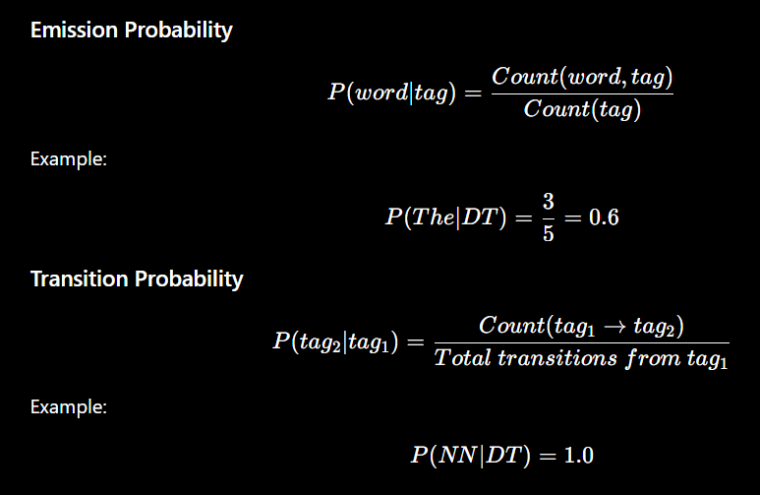

3. Simple Python Program

training_data = [
[("The","DT"),("boy","NN"),("eats","VBZ"),("rice","NN")],
[("The","DT"),("girl","NN"),("drinks","VBZ"),("milk","NN")],
[("A","DT"),("cat","NN"),("drinks","VBZ"),("milk","NN")],
[("The","DT"),("dog","NN"),("chases","VBZ"),("cat","NN")],
[("A","DT"),("teacher","NN"),("teaches","VBZ"),("students","NNS")],
[("Students","NNS"),("study","VBP"),("English","NN")],
[("Birds","NNS"),("fly","VBP"),("high","RB")],
[("Children","NNS"),("play","VBP"),("games","NNS")]
]

tag_count = {}
emission_count = {}
transition_count = {}
start_count = {}
tags = []

for sentence in training_data:
start_count[sentence[0][1]] = start_count.get(sentence[0][1], 0) + 1

for i in range(len(sentence)):
word, tag = sentence[i]

if tag not in tags:
tags.append(tag)

tag_count[tag] = tag_count.get(tag, 0) + 1

if tag not in emission_count:
emission_count[tag] = {}

emission_count[tag][word] = emission_count[tag].get(word, 0) + 1

if i < len(sentence) - 1:
next_tag = sentence[i + 1][1]

if tag not in transition_count:
transition_count[tag] = {}

transition_count[tag][next_tag] = transition_count[tag].get(next_tag, 0) + 1

print("EMISSION PROBABILITIES")

for tag in emission_count:
for word in emission_count[tag]:
probability = emission_count[tag][word] / tag_count[tag]
print(word, "/", tag, "=", round(probability, 3))

print("\nTRANSITION PROBABILITIES")

for tag in transition_count:
total = sum(transition_count[tag].values())

for next_tag in transition_count[tag]:
probability = transition_count[tag][next_tag] / total
print(tag, "->", next_tag, "=", round(probability, 3))

def emission(tag, word):
if tag in emission_count and word in emission_count[tag]:
return emission_count[tag][word] / tag_count[tag]
return 0.0001

def transition(tag1, tag2):
if tag1 in transition_count and tag2 in transition_count[tag1]:
total = sum(transition_count[tag1].values())
return transition_count[tag1][tag2] / total
return 0.0001

def viterbi(sentence):

v = [{}]
path = {}

for tag in tags:
start_prob = start_count.get(tag, 0) / len(training_data)
v[0][tag] = start_prob * emission(tag, sentence[0])
path[tag] = [tag]

for i in range(1, len(sentence)):
v.append({})
new_path = {}

for current in tags:
best_prob = -1
best_tag = None

for previous in tags:
prob = v[i-1][previous] * transition(previous, current) * emission(current, sentence[i])

if prob > best_prob:
best_prob = prob
best_tag = previous

v[i][current] = best_prob
new_path[current] = path[best_tag] + [current]

path = new_path

best_tag = max(v[-1], key=v[-1].get)

return path[best_tag]

sentence = ["The", "cat", "drinks", "milk"]

result = viterbi(sentence)

print("\nPREDICTED TAGS")

for word, tag in zip(sentence, result):
print(word + "/" + tag)

4. Important Results

Emission Examples
Word | Tag | Probability
The | DT | 0.6
cat | NN | 0.2
drinks | VBZ | 0.4
milk | NN | 0.2
Transition Examples
Transition | Probability
DT → NN | 1.0
NN → VBZ | 1.0
VBZ → NN | 0.8

5. Final Predicted Output

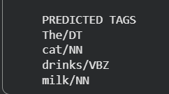

Final POS Tag Sequence

DT NN VBZ NN​

Rubrics for Calculation

Criteria | Weightage (%) | Level 4 (Exemplary) | Level 3 (Proficient) | Level 2 (Developing) | Level 1 (Beginning)
Understanding of Scenario | 20% | Demonstrates clear and complete understanding of the scenario and context | Shows good understanding with minor gaps | Partial understanding; misses key aspects | Misinterprets or fails to understand the scenario
Identification of Key Issues | 20% | Accurately identifies all relevant issues and factors involved | Identifies most key issues with minor omissions | Identifies limited issues; some irrelevant points | Unable to identify key issues
Application of Concepts | 25% | Applies appropriate concepts effectively to address the scenario | Applies concepts with minor errors | Limited or partially correct application | Unable to apply relevant concepts
Decision Making | 20% | Makes well-reasoned, logical decisions with strong rationale | Makes reasonable decisions with some justification | Makes weak decisions with limited justification | No clear decisions made or rationale provided
Clarity of Response | 15% | Response is clear, structured, and logically presented | Generally clear with minor issues | Somewhat unclear or poorly structured | Disorganized and difficult to understand

Q. No. / Criteria Level | Understanding of Scenario | Identification of Key Issues | Application of Concepts | Decision Making | Clarity of Response | Sub. Total | Total %
1 | 4 | 3 | 3 | 3 | 3 | 16 | 80
2 | 4 | 3 | 3 | 3 | 3 | 16
3 | 4 | 3 | 3 | 3 | 3 | 16
4 | 4 | 3 | 3 | 3 | 3 | 16
5 | 4 | 3 | 3 | 3 | 3 | 16

Faculty In-charge | Course Coordinator | Program Director
Signature: _______________ | Signature: _______________ | Signature: _______________
Date: ___________________ | Date: ___________________ | Date: ___________________

